## **Name : Junaid Ahmed**

## **ID: BIT-23F-030**

## **Section: “3A”**

## **Lab: 08**

## **Subject: Artificial Intelligence**

## **Program: BS-IT**

TASK-01 : Write a Python class named Car that represents a car. The class should have the following attributes:

## make: the car's make (e.g., "Toyota")

## model: the car's model (e.g., "Corolla")

## year: the car's manufacturing year (e.g., 2020)

## mileage: the number of miles driven by the car.

## The class should have the following methods:

## __init__(self): Constructor to initialize the car's attributes.

## display_info(): Displays the car's information (make, model, year, mileage).

## drive(miles): Increases the mileage by the specified number of miles

## Program:

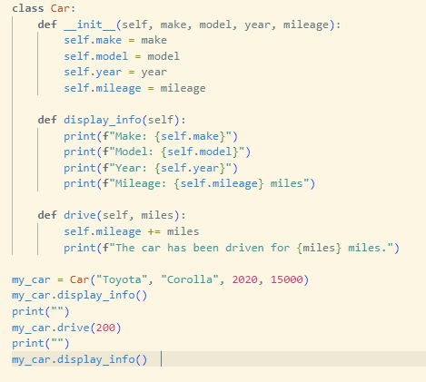

## Output:

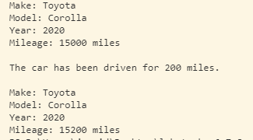

TASK-02: Write a Python class named Student that represents a student. The class should have the following attributes:

## name: the student's name.

## age: the student's age.

## marks: a list of the student's marks.

## The class should have the following methods:

## __init__(self): Constructor to initialize the student's attributes.

## add_marks(self, marks): Adds a list of marks to the student's marks list.

## average_marks(self): Calculates and returns the average of the student's marks.

## display_info(self): Displays the student's information (name, age, average marks).

## Program:

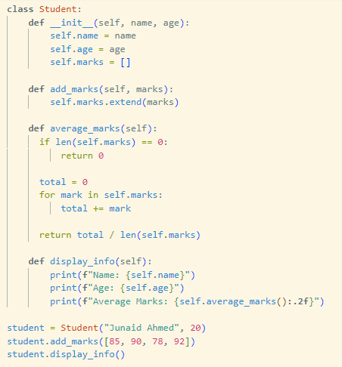

## Output:



## TASK-03 : Write a Python class named BankAccount that represents a bank account. The class should have the following attributes:

## account_holder: the name of the account holder.

## balance: the balance of the account.

## The class should have the following methods:

## __init__(self): Constructor to initialize the account holder's name and balance.

## deposit(self, amount): Deposits an amount into the account.

## withdraw(self, amount): Withdraws an amount from the account if there are sufficient funds.

## display_balance(self): Displays the current balance of the account.

## Program:

## 

## Output:

